**EXERCISE 3.1**

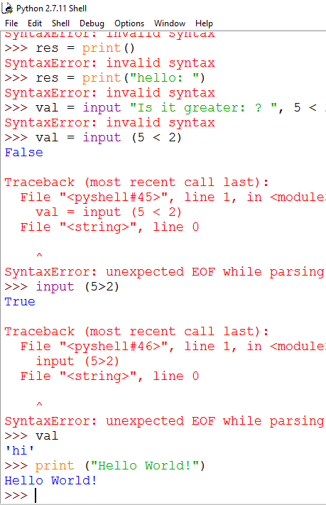

Figure 1 print “Hello World” OR print (“Hello World”)

**EXERCISE 3.2**

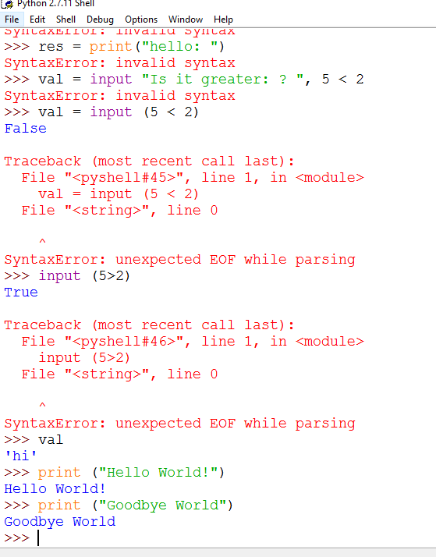

Figure 2 print ("Goodbye World")

**EXERCISE 4.1**

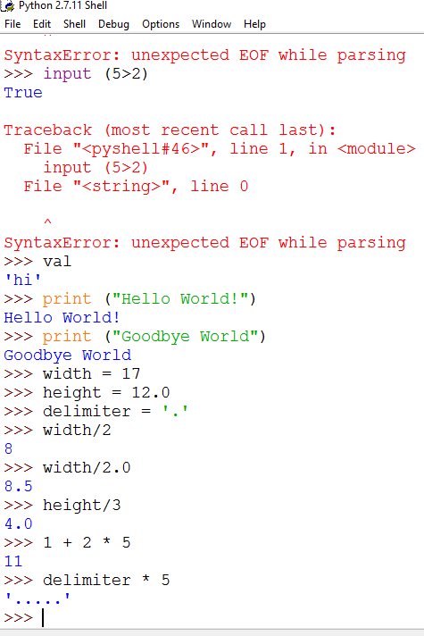

Figure 3 Exercise 4.1